1. 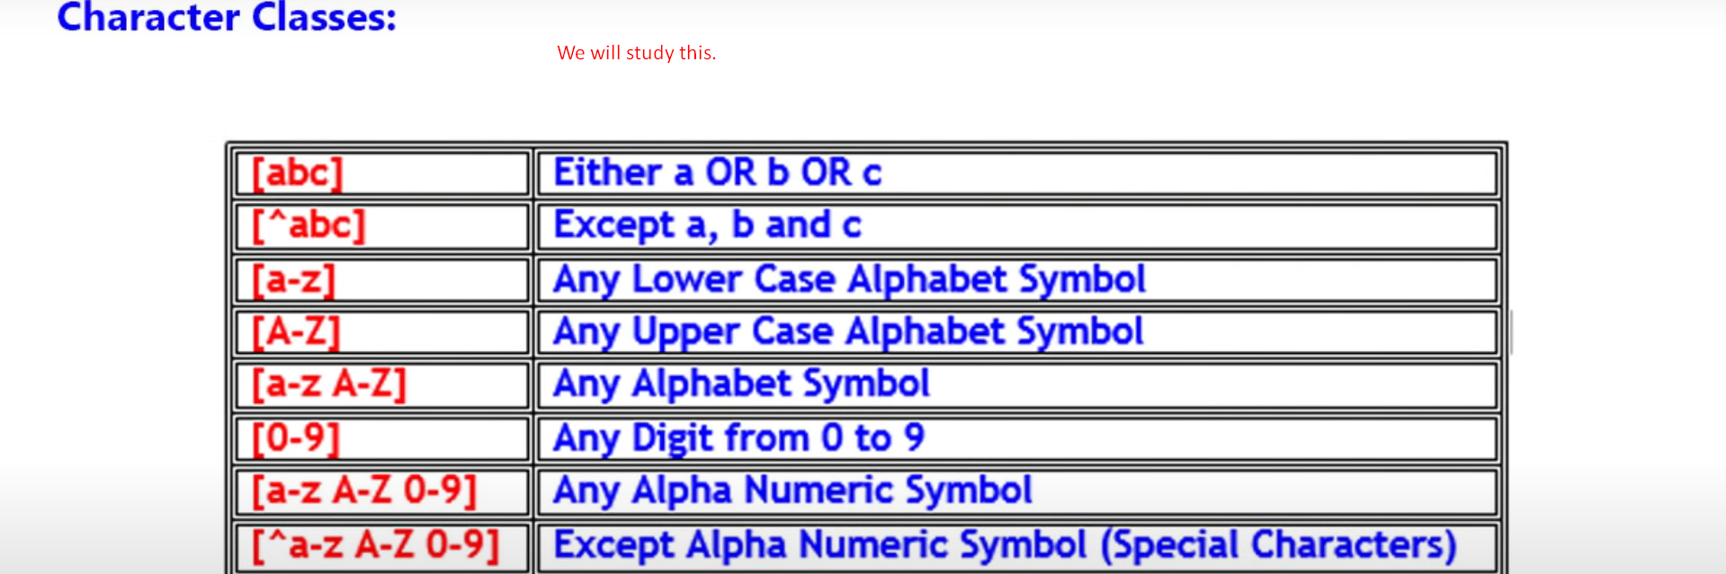
2. Pattern and Regular Expression are used interchangeably.
3. Let’s study different kinds of patterns.

## Character Classes

1. Class means here a group of things.
2. So, when we are searching a group of something, we go for Character classes.
3. 